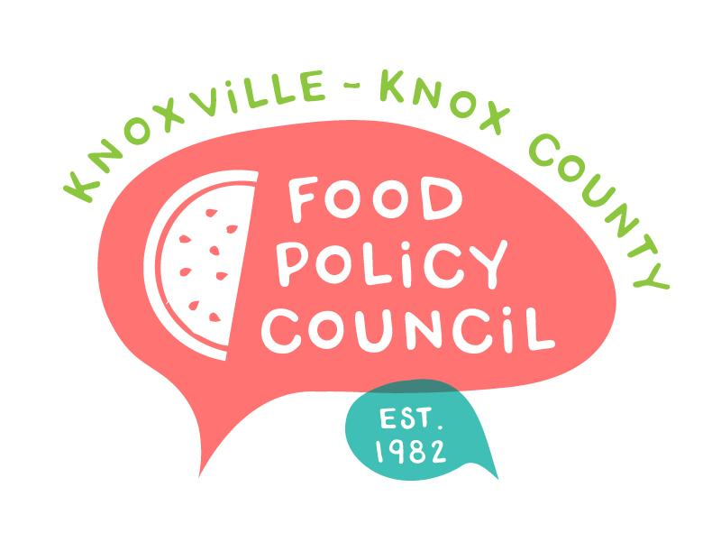
Knoxville-Knox County Food Policy Council Agenda
8:30-10:00 AM
May 21st, 2025

- 8:30: 8:35: Welcome and Introductions: Marisa Moazen
- 8:35 – 9:15: Organizational & Committee Updates
  - FPC Recommendations Update (Ariel)
  - PhD Student Working Waste and Recovery Plan (Kimberly)
  - Survey Results (Kimberly)
  - Council Updates
- 9:15 – 10:00: FPC Branding Feedback Session: Ashlee Mays

Upcoming Meetings

June 18, 2025
Food Policy Council Mtg
8:30-10:00 AM
United Way of Greater Knoxville

