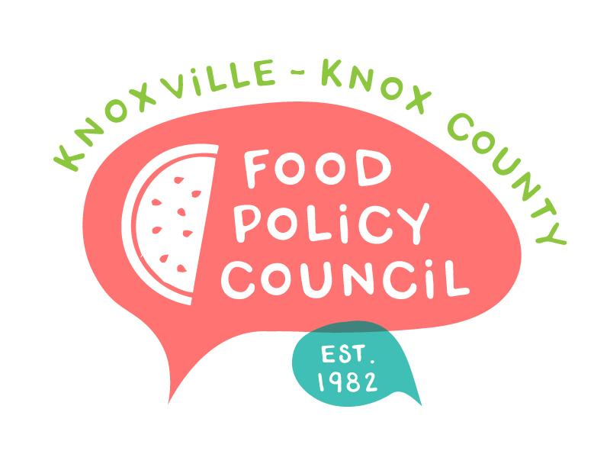
Knoxville-Knox County Food Policy Council
Agenda
8:30-10:00 AM
September 18, 2024
United Way of Greater Knoxville

- 8:30: 8:45: Welcome and Introductions
  - Meeting Minutes Approval if Quorum (Feb – Aug)
- 8:45 – 9:15: How Small Farms Weather the Storm:
Amanda McHale and Jennifer Russomanno
- 9:15 - 10 am: Organizational Updates and Announcements
  - KEMA participation opportunity

Next Meeting

October 16, 2024
TBD
8:30 – 10 am, United Way of Greater Knoxville

October 25, 2024
People’s Food Plan Coalition Launch
9 – 11 am

November 20, 2024
Nominations, Bylaws
2025 Planning
8:30 – 10 am, United Way of Greater Knoxville

