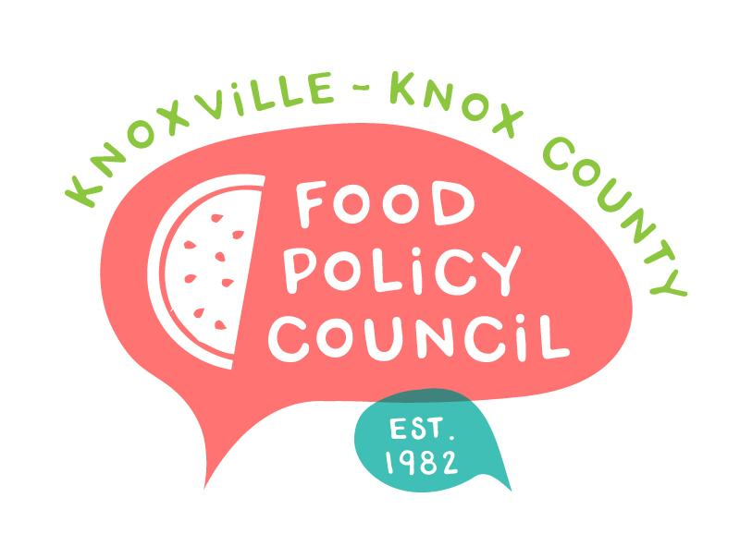
Knoxville-Knox County Food Policy Council
Agenda
8:30-10:00 AM
June 26, 2024
United Way of Greater Knoxville

- 8:30: 8:45: Welcome and Introductions
- 8:45 – 9:15: Market Basket Study Presentation: Dr. Spence Students
- 9:15 – 9:45: People’s Food Plan: Madelyn Howe, Kimberly Pettigrew
- 9:45 - 10 am: Organizational Updates and Announcements

Next Meeting

July 17, 2024
*Field Trip*
8:30 – 10 am
CAC Beardsley Farm

August 21, 2024
KCDC: Transforming Western Heights, Section 8 Needs Assessment, and Reconnecting Communities Presentation
8:30 – 10 am
United Way of Greater Knoxville

