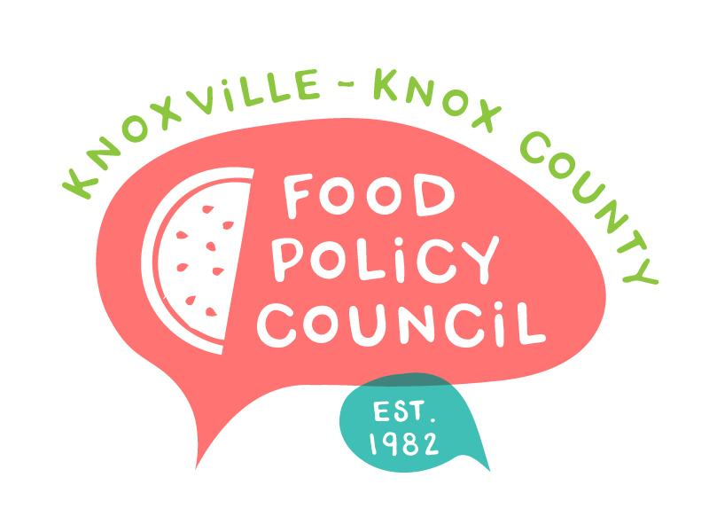
Knoxville-Knox County Food Policy Council
Agenda
8:30-10:00 AM
May 15, 2024
United Way of Greater Knoxville

- 8:30: 8:45: Welcome and Introductions
- 8:45 – 9:15: CQI Process for Food Systems: Dr. Spence PhD Students
- 9:15 – 9:45: Food Supports for School-Aged Children: Sandra Wairimu, Imelda Gutierrez, Tyler Myers
- 9:45 - 10 am: Organizational Updates and Announcements

Next Meeting

June 26, 2024
UT Students Market Basket Study
People’s Food Plan: Madelyn and Kimberly
8:30 – 10 am
United Way of Greater Knoxville

July 17, 2024
*Field Trip*
8:30 – 10 am
CAC Beardsley Farm

