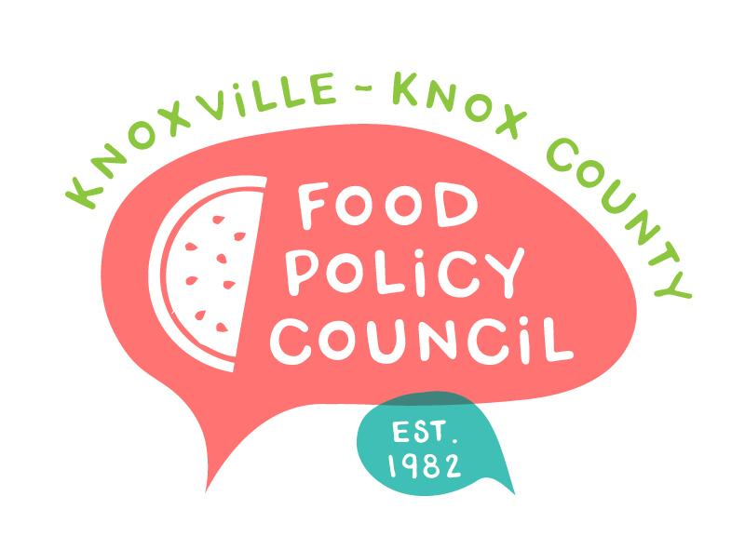
Knoxville-Knox County Food Policy Council
Agenda
8:30-10:00 AM
November 15, 2023
United Way of Greater Knoxville

- 8:30: Welcome and Introductions: Bailey Foster
- 8:45 – 9:00: Approval of Past Meeting Minutes: Bailey Foster
- 9:00 – 9:10: Bylaws Committee: Rylan Thompson
- 9:10 – 9:20: Nominations Committee: Wade Seifert
  - Nominations Committee Slate Approval
  - Executive Committee Approval
- 9:20 - 9:50: Knoxville-Knox County Planning Presentation: Jessie Hillman
- 9:50 - 10:00: Organizational Updates and Announcements: : Bailey Foster

Upcoming Meetings

December 20
Holiday Party and 2024 Final Planning
United Way of Greater Knoxville

January 17, 2023
First meeting of the year!
United Way of Greater Knoxville

