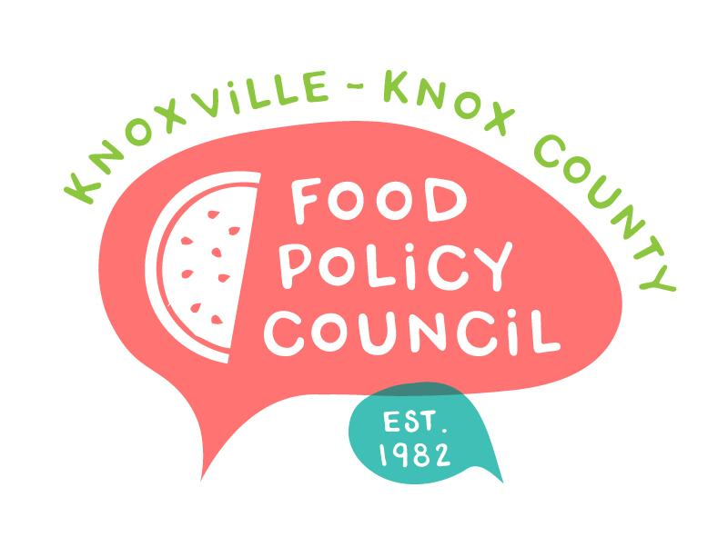
Knoxville-Knox County Food Policy Council
Agenda
8:30-10:00 AM
March 20, 2024
United Way of Greater Knoxville

- Welcome and Introductions: Bailey Foster
- Community Schools 101: Adam Fritts, Director of Community Schools
- December and January Minutes Approval: Bailey Foster
- Policy Updates
  - Advance Knox
  - Federal and State
- Organizational Updates and Announcements: Bailey Foster
- Adjourn

Next Meetings

April 17, 2024
Annual Retreat
8:30 – 10:30 am
United Way of Greater Knoxville

May 15, 2024
UT Students Market Basket Study
Food Supports for School-aged children: Sandra Wairimu and Imelda Gutierrez
8:30 – 10 am
United Way of Greater Knoxville

