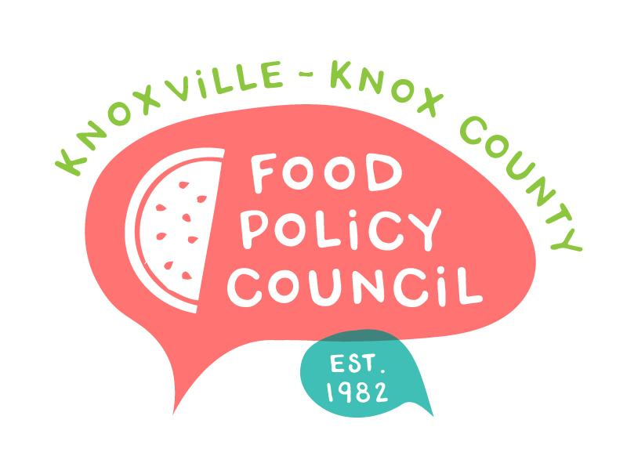
Knoxville-Knox County Food Policy Council
Agenda
8:30-10:00 AM
February 21, 2024
United Way of Greater Knoxville

- Welcome and Introductions: Bailey Foster
- December Minutes Approval: Bailey
- Nominations Update: Kimberly
- Policy Updates
  - Advance Knox: Jessie Hillman
  - Federal and State: including Summer EBT win!
- The Year Ahead: Bailey Foster: Speaker and Field Trip Feedback
- Organizational Updates and Announcements: Bailey Foster
- Adjourn

Next Meetings
March 20, 2024
Voting Meeting
8:30 – 10 am
United Way of Greater Knoxville

April 17, 2024
Annual Retreat
8:30 – 10:30 am
United Way of Greater Knoxville

