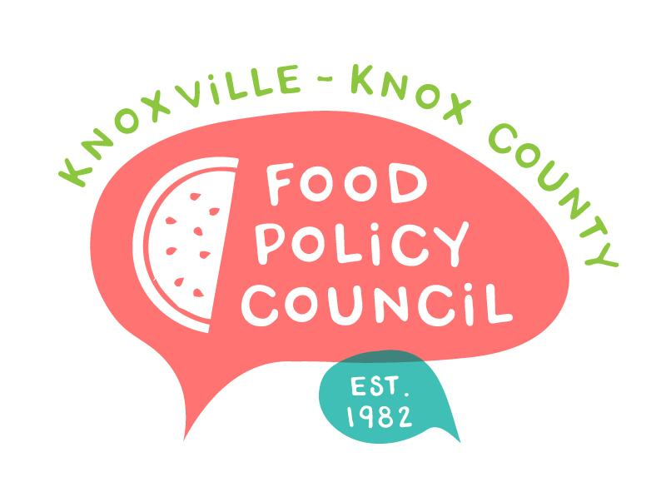
Knoxville-Knox County Food Policy Council
Agenda
8:30-10:00 AM
March 22, 2023
United Way of Greater Knoxville

- Welcome and Introductions: Bailey Foster
- Committee Nominations: Bailey Foster
- Organizational Updates and Announcements: Bailey Foster
- Presentation from Kaki Reynolds on the TANF Opportunity Pilot and the East TN Collaborative
- Asset mapping activity led by Lillie Sutton and Sandra Wairimu
- Adjourn

Next Meeting
April 19, 2023
Education, Networking, Policy Updates
8:30 – 10 am
United Way of Greater Knoxville

