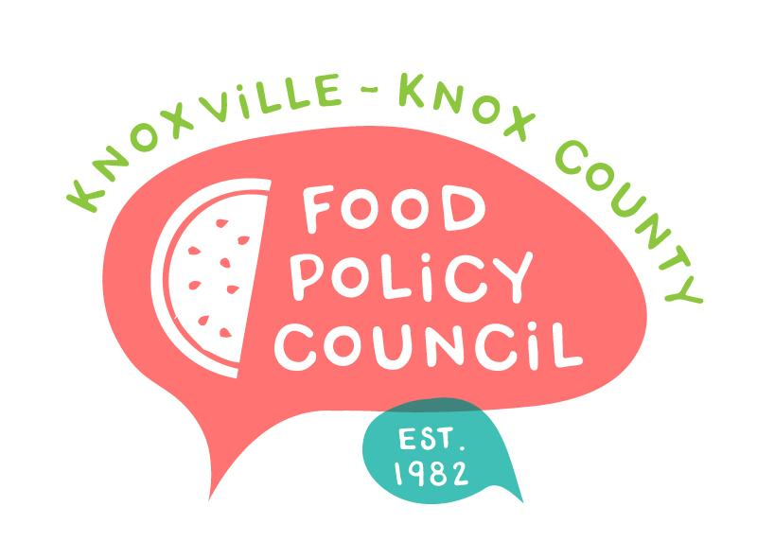
Knoxville-Knox County Food Policy Council Agenda
8:30-10:00 AM
March 26th, 2025

- 8:30: 8:45: Welcome and Introductions: Marisa Moazen
- 8:45 – 9:15: Organizational & Committee Updates
  - Executive Committee Announcements
  - Policy Updates
  - Council Updates
- 9:15 - 10 am Food Waste Recovery
  - Mackenzie Read | City of Knoxville Solid Waste
  - Ruth Ivey | Second Harvest

Upcoming Meetings

March 25, 2025
Food Distribution Working Group
2:00-3:30 PM
Knox Pride Center

April 16, 2025
Food Policy Council Mtg
8:30-10:00 AM
Working Meeting

April 25, 2025
HFFI Community Advisory Board
9-11 AM
The Point

