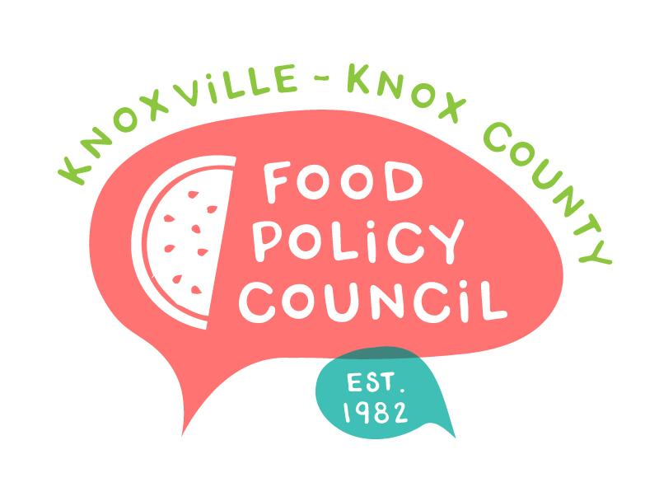
Knoxville-Knox County Food Policy Council Agenda
8:30-10:00 AM
January 15th, 2025

- 8:30: 8:45: Welcome and Introductions: Marisa Moazen
- 8:45 – 9:00: Organizational & Committee Updates
  - Announcements
- 9:00 - 10 am: Food in Schools (Right to Access)
  - Brett Foster | Knox County Schools Nutrition
  - Charlotte Rodina & Maryl Burke | Beardsley Farm
  - Sarah Wharton | Little Chefs Big Change

Upcoming Meetings

January 21, 2025
Food Distribution Working Group
2:00-3:30 PM
Knox Pride Center

January 31, 2025
HFFI Launch Party
9:00-11:00 AM
Regas Building

February 7, 2025
Farm to School Workshop
9:00-3:00 PM
UT Conference Center

February 19, 2025
Food Policy Council Mtg
8:30-10:00 AM

