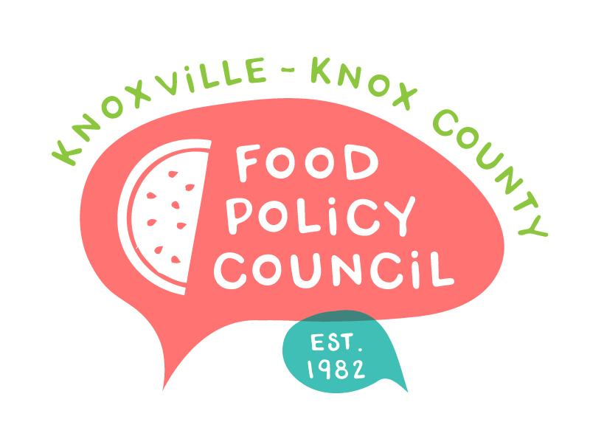
Knoxville-Knox County Food Policy Council
Agenda
8:30-10:00 AM
September 20, 2023
United Way of Greater Knoxville

- 8:30: Welcome: Bailey Foster
- 8:35 – 9:20: What were our results of coming together over the past year?
  - Small Groups (Introductions and Discussion)- 30 min
    - What were our successes? Anticipated and unexpected?
    - What did we learn?
    - What partnerships or collaborations emerged?
    - What are our opportunities for growth?
  - Full Group Share Out- 15 min
- 9:20 – 9:40 Where would we like to grow and improve?
  - What are our goals for 2024?
  - What does success look like in this space?
  - What are our challenges?
- 9:40 - 10:00: 2024 Planning Input
  - Membership
    - Who are we missing at the table?
    - How are we addressing diversity, equity, and inclusion?
  - What would we like to learn?
- Adjourn

Next Meetings

October 18, 2023
Volunteer East TN, 211, Community Garden Data Share-out
Location and Final Details in Planning

Remember that our Committees need to meet!
Bylaws: Rylan Thompson (Chair), Lauren Woods, Tiara Lady Wilson
Nominations: Wade Seifert (chair), Jessie Hilman, Marisa Moazen

November 15, 2023
Volunteer East TN, 211, Community Garden Data Share-out
Location and Final Details in Planning

