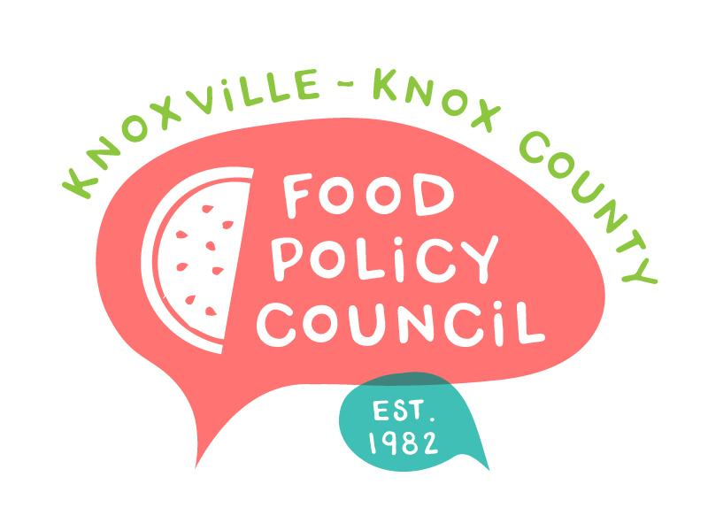
Knoxville-Knox County Food Policy Council
Agenda
8:30-10:00 AM
October 18, 2023
United Way of Greater Knoxville

- 8:30: Welcome and Introductions: Bailey Foster
- 8:45 – 9:00: Community Garden Alliance Report Share-Out: Katy Neusner
- 9:00 – 9:10: Volunteer East TN 101 for Nonprofits: Kate Barnett
- 9:10 – 9:30: Introduction to 211: Russ Jensen
- 9:40 - 10:00: 2024 Planning Input Continuation
  - Membership
    - Who are we missing at the table?
    - How are we addressing diversity, equity, and inclusion?
  - What would we like to learn?
- Adjourn

Next Meetings

Remember that Committees need to meet before November 15 with plans!
Bylaws: Rylan Thompson (Chair), Lauren Woods, Tiara Lady Wilson
Nominations: Wade Seifert (chair), Jessie Hillman, Marisa Moazen

November 15, 2023
Volunteer East TN, 211, Community Garden Data Share-out
Location and Final Details in Planning

