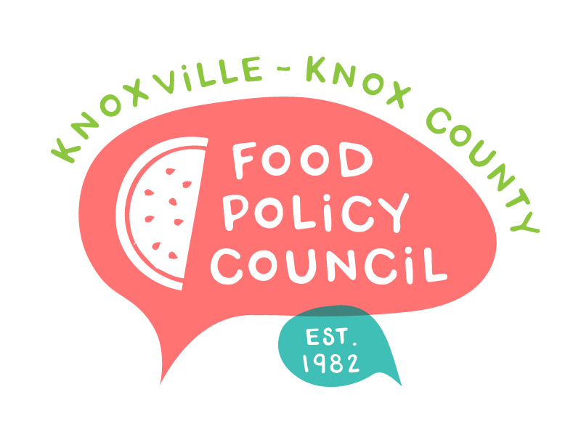
Knoxville-Knox County Food Policy Council
Agenda
8:30-10:00 AM
April 15, 2021
Virtual via Zoom

- Welcome, roll call
- Approve Minutes (February) – Motion/Vote
- State and Federal Legislative Updates
- Committee Updates
- Introduction to Equity and Diversity Statement
- Organizational Updates and Announcements

Notes:

The next Food Policy Council Meeting will be our annual retreat facilitated by the Johns Hopkins Center for a Livable Future held via zoom on Thursday, May 20 from 8:30 – 10 am

