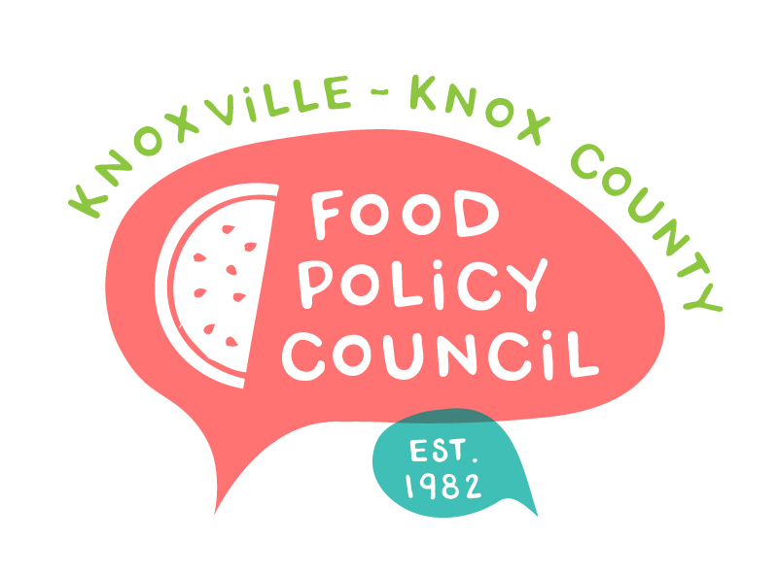
Knoxville-Knox County Food Policy Council
Agenda
8:30 - 10:00 a.m.
March 18, 2021
Virtual via Zoom

- Welcome, roll call
- State and Federal Legislative Updates
- Speakers and Discussion
  - LaKenya Middlebrook, Attorney and director of Police Advisory and Review Committee, City of Knoxville
  - Darris Upton, Diversity Development Manager, Knox County
- Organizational Updates and Announcements

Notes:

- Data committee and structural committee will begin meeting in April

- The next Food Policy Council Meeting will be a voting meeting held via zoom on Thursday, April 15 from 8:30 – 10:00 a.m.

